

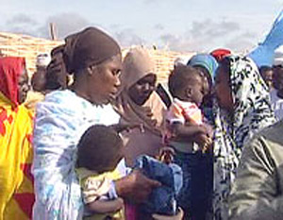

With the Support of MADRE and Zenab,
the First Women’s Farmers’ Union Has Been Created

Fatima Ahmed, an agricultural engineer and the president of MADRE’s Sudanese sister organization Zenab for Women in Development, recently reported the devastating conditions in which women farmers from Al Qadarif – eastern region - in Sudan work. MADRE and our Sudanese partner are confronting climate change and the lack of farming tools.

Most women farmers do not have the basic working tools that allow them to perform their job efficiently. As a result, they must spend an entire day just to work on a few square meters of their land. Tools to increase efficiency are available from the Department of Agriculture, but are only provided to farmers’ unions, which are only made up of men. Historically, women have not been allowed to create unions and consequently, they have no access to these benefits. With the support of MADRE and Zenab, the first women’s farmers’ union has been created. The women’s determination, together with trainings on farming techniques, human rights and women rights, and basic health workshops will make a palpable difference. MADRE is also providing ploughing animals.

